ASSIGNMENT 1

BOOKS AND BYTES

NAME : HARINI VR

ROLLNO : 20AD019

1.Creating database for books and bytes :

CREATE DATABASE BOOKSDB2;

USE BOOKSDB2;

CREATE TABLE BOOKS2(

BOOKNO INT PRIMARY KEY,

TITLE VARCHAR(50),

AUTHOR VARCHAR(75),

PUBLICATION_YEAR INT,

PRICE INT

);

INSERT INTO BOOKS2 VALUES(1,"SQL FOR BEGINNERS","SHANE BLACK",2003,1600);

INSERT INTO BOOKS2 VALUES(2,"SQL COOKBOOK","ANTHONY MOLINORA",2005,199);

INSERT INTO BOOKS2 VALUES(3,"GETTING STARTED WITH SQL","THOMAS NIELS",2006,1600);

INSERT INTO BOOKS2 VALUES(4,"SQL IN 10 MINUTES","BEN FORTA",2011,222);

INSERT INTO BOOKS2 VALUES(5,"T-SQL FUNDAMENTALS","ITZIK BEN-GAN",2014,2403);

INSERT INTO BOOKS2 VALUES(6,"SQLPRACTICE PROBLEMS","SYLVIA MOESTL VASLIK",2013,2403);

A.Retrive all the books from the database :

SELECT *FROM BOOKS2;

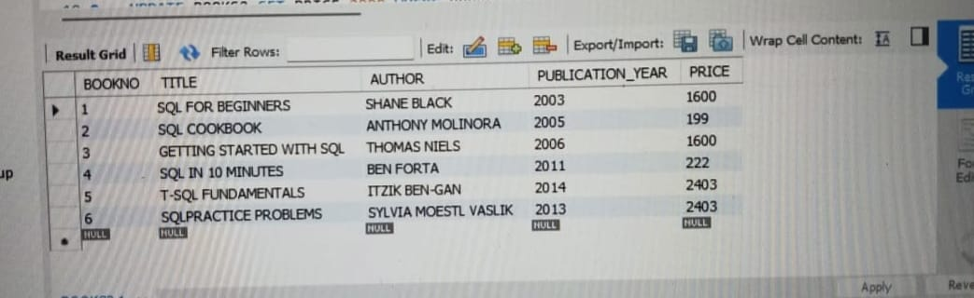

B.Retrive the details of a book based on its title :

SELECT TITLE FROM BOOKS2;

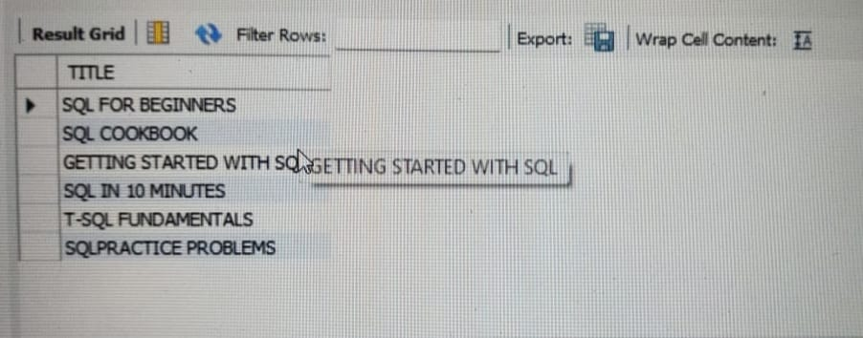

C.Update the price of a book :

UPDATE BOOKS2 SET PRICE=2000 WHERE BOOKNO=1;

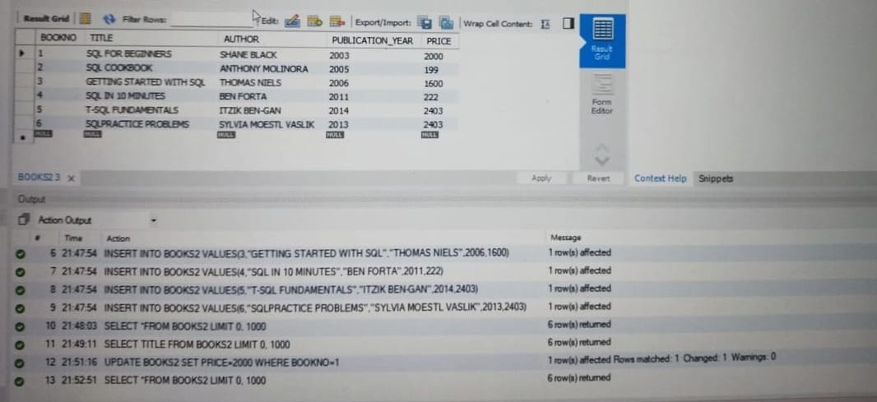

D.Delete a book from the database based on its title :

DELETE FROM BOOKS2 WHERE BOOKNO=4;

